 Pet Allergies 

Signs of Allergies:
An allergy is a reaction that involves the body’s immune system resulting in inflammation. Allergies in cats and dogs can manifest in several different ways but most often involve itchy skin and can lead to secondary bacterial or yeast infections. Your pet may itch, lick, and/or chew skin on paws, groin, neck, ears, or all over their body. Often allergies take time to develop; most animals will not start to show signs of allergies until they are young adults (seasonal allergies) to middle aged (food allergies).

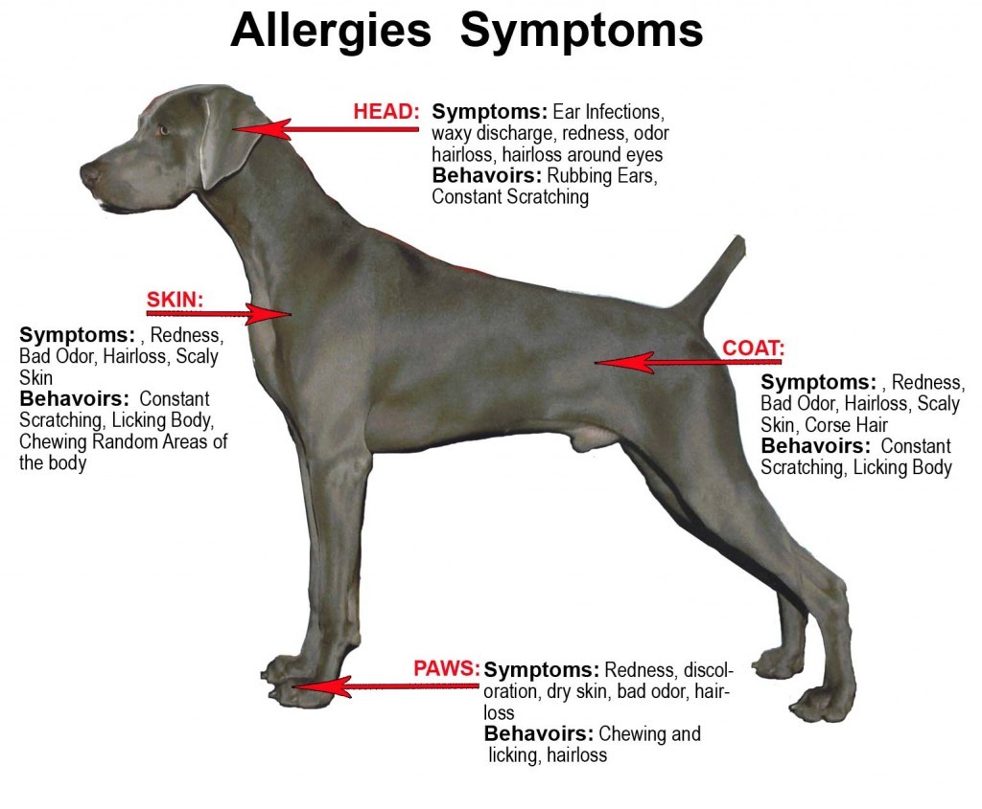
Types of Allergies:
The constant itching and scratching caused by allergies can be very frustrating for both pets and their owners. There are a few different forms of allergies; environmental, seasonal, and food based allergies.
Seasonal (Outdoor) = allergies to pollens, trees, grass, ragweed, etc.
Food = allergies to an food ingredient usually the protein (beef, chicken) or carbohydrate source (wheat, corn)
Environmental (Indoor) = allergies to mold or dust mites in our homes

**It is important to rule out some other medical issues such as external parasites (fleas or mites) or skin infections. Skin irritation caused by allergies can allow bacteria or yeast to grow which cause their own itch response and can complicate treatment. This is why it is important to bring your pet to the veterinarian for an exam when they suffer from itchy skin.

Treatment:
Different allergies require different treatments, so it is important to first try to determine what type of allergy your pet is suffering from. First, it depends on whether or not your pet is itchy all the time or just during certain times of the year/seasons. If this is the case, and your pet is NOT itchy in the winter months, he/she likely has a seasonal allergy. These symptoms can be decreased with over the counter anti-histamines such as Benadryl, Claratin, or Zyrtec. Also omega 3 supplements (not just a normal fish oil) can help decrease inflammation in the skin. Be sure to ask your veterinarian before starting any medications and for the proper dose. Other prescription medications and/or shampoos may be prescribed as seen fit by your veterinarian.

If your pet is itchy all year round, especially in the winter months, then he/she likely has a food allergy. Most often the allergy in food is to the protein or carbohydrate source within the food. The most common pet food allergies are to ingredients such as: beef, chicken, & grains (wheat & corn in particular). So, for that reason we recommend doing a food trial and eliminating these food items from your pet’s diet. However, you need to think of EVERYTHING your pet eats, not just his/her food. You will also need to eliminate things such as treats, rawhides, table scraps, flavored medications, and access to other pet’s food. Anything your pet ingests that has any of these potential allergens needs to be eliminated completely to do an appropriate food trial.

Food Trial:
There are two main options for doing an appropriate food trial. You can purchase a food from the store that has a “novel protein”. This term is used for a protein source that your pet has not eaten before, some popular options are rabbit, venison, fish, & duck. Ideally eliminate all beef and chicken and make sure that there is only one protein source and one carbohydrate source in the food. Sometimes using a “Grain Free” food is ideal to eliminate the problem protein and carbohydrate from the diet all at once. Many of the “novel protein” diets already come this way, examples include duck & pea or fish & potato.

A second option for a food trial is a hydrolyzed diet that a conventional protein source is used but the protein is broken down into molecules too small to stimulate the immune system and cause a reaction. The one we recommend most is Royal Canin HP (hydrolyzed protein). Using this diet is often the fastest way to see if a food trail is going to work for your pet since it is hard to pin point exactly what your pet is allergic to.
Keep in mind that a food trial takes time! This is not a quick fix to allergies. It takes several months for one protein molecule to enter and then completely leave the body. An appropriate food trail is a minimum of 8 weeks to see if your pet will have a favorable response to that particular food or not.

Recommendations For Your Pet:
Antihistamines: Benadry/Diphenhydramine 25mg, Dose:
Claritin/Loratidine 10mg, Dose:
Zyrtec/Cetirizine 10mg, Dose:
Omega 3:
Antibiotics:
Yeast Medication:
Flea Treatment/Prevention:
Prednisone/Steroid:
Apoquel:
Food Trial (2 month minimum):
Other:

